Creating amaven project and create a project

And create a package named as AssignmentDEMO-001

Test-1-post

Test-2-get

Test-3-Delete

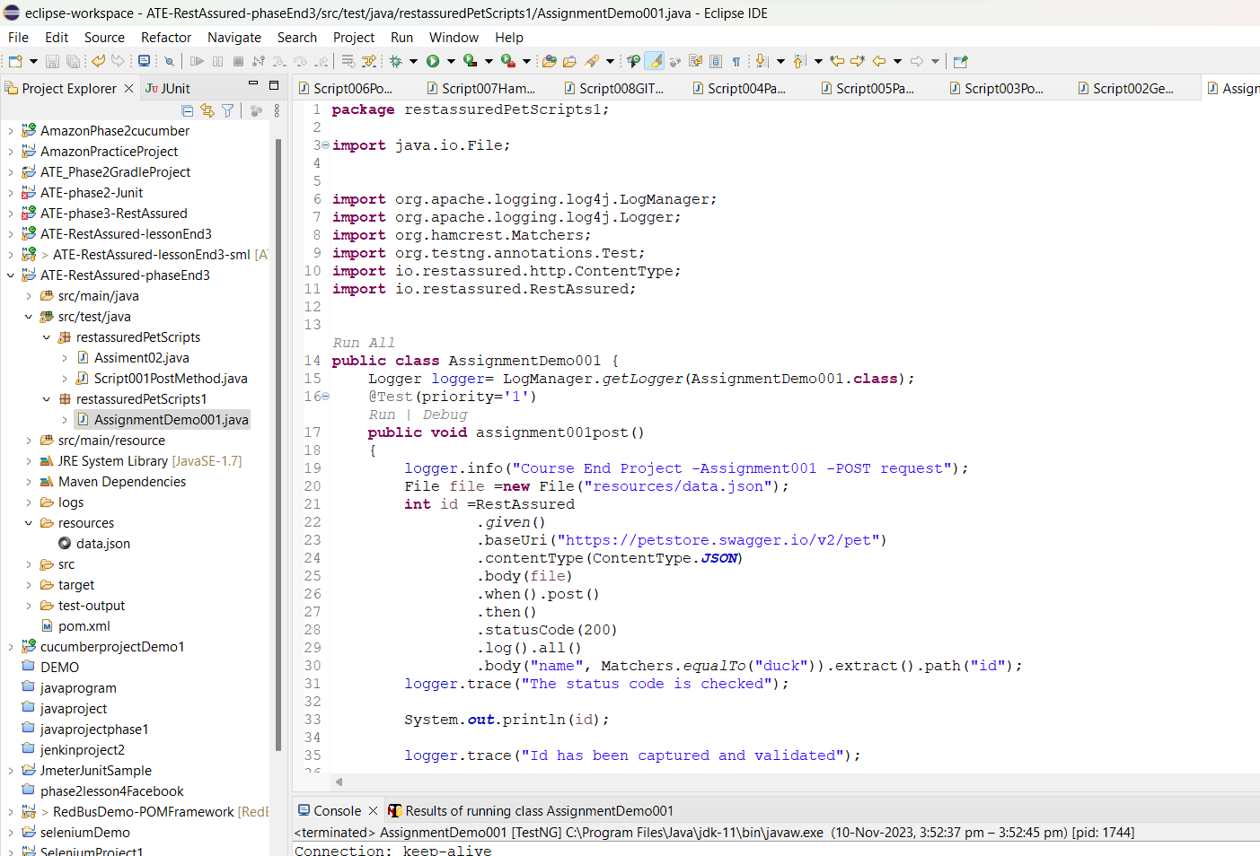

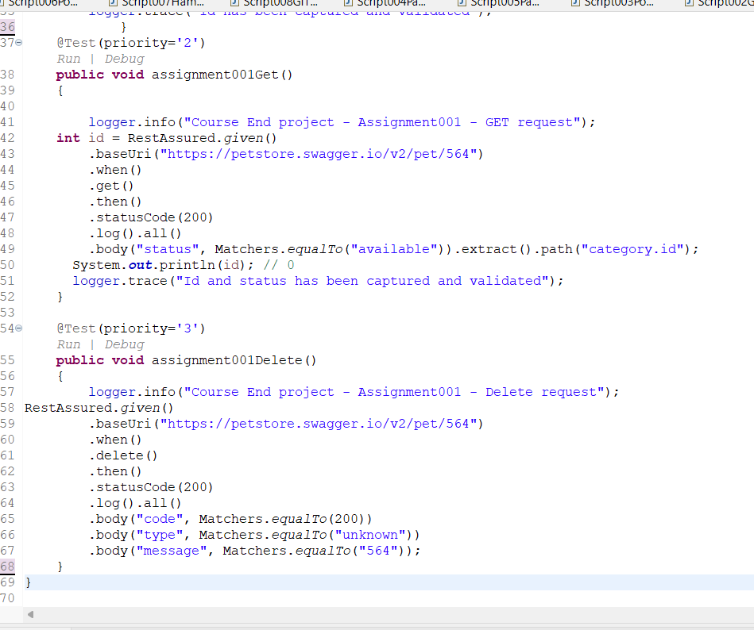

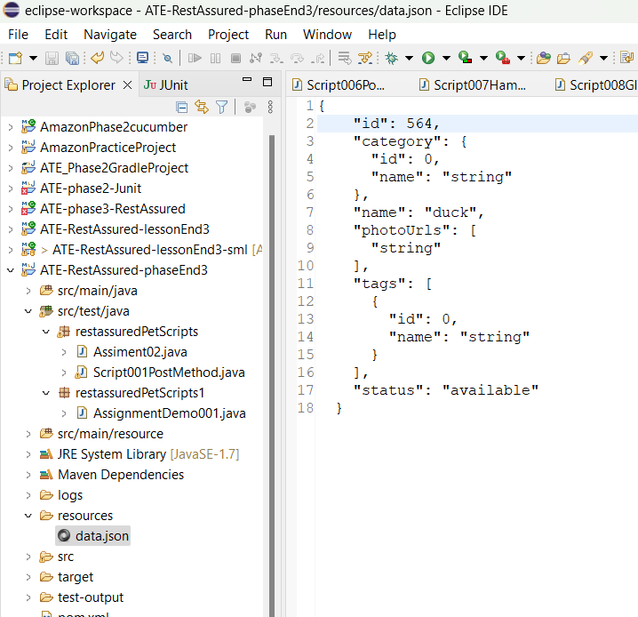

**package** restassuredPetScripts1;

**import** java.io.File;

**import** org.apache.logging.log4j.LogManager;

**import** org.apache.logging.log4j.Logger;

**import** org.hamcrest.Matchers;

**import** org.testng.annotations.Test;

**import** io.restassured.http.ContentType;

**import** io.restassured.RestAssured;

**public** **class** AssignmentDemo001 {

Logger logger= LogManager.*getLogger*(AssignmentDemo001.**class**);

@Test(priority='1')

**public** **void** assignment001post()

{

logger.info("Course End Project -Assignment001 -POST request");

File file =**new** File("resources/data.json");

**int** id =RestAssured

.*given*()

.baseUri("https://petstore.swagger.io/v2/pet")

.contentType(ContentType.***JSON***)

.body(file)

.when().post()

.then()

.statusCode(200)

.log().all()

.body("name", Matchers.*equalTo*("duck")).extract().path("id");

logger.trace("The status code is checked");

System.***out***.println(id);

logger.trace("Id has been captured and validated");

}

@Test(priority='2')

**public** **void** assignment001Get()

{

logger.info("Course End project - Assignment001 - GET request");

**int** id = RestAssured.*given*()

.baseUri("https://petstore.swagger.io/v2/pet/564")

.when()

.get()

.then()

.statusCode(200)

.log().all()

.body("status", Matchers.*equalTo*("available")).extract().path("category.id");

System.***out***.println(id); // 0

logger.trace("Id and status has been captured and validated");

}

@Test(priority='3')

**public** **void** assignment001Delete()

{

logger.info("Course End project - Assignment001 - Delete request");

RestAssured.*given*()

.baseUri("https://petstore.swagger.io/v2/pet/564")

.when()

.delete()

.then()

.statusCode(200)

.log().all()

.body("code", Matchers.*equalTo*(200))

.body("type", Matchers.*equalTo*("unknown"))

.body("message", Matchers.*equalTo*("564"));

}

}

Output-

Click on run button.

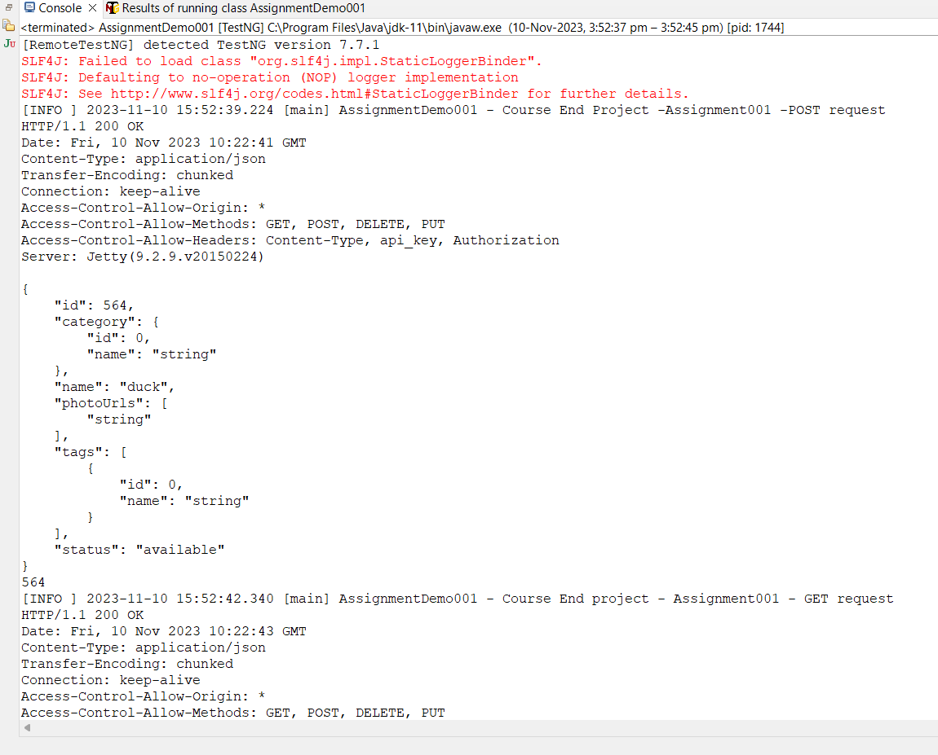

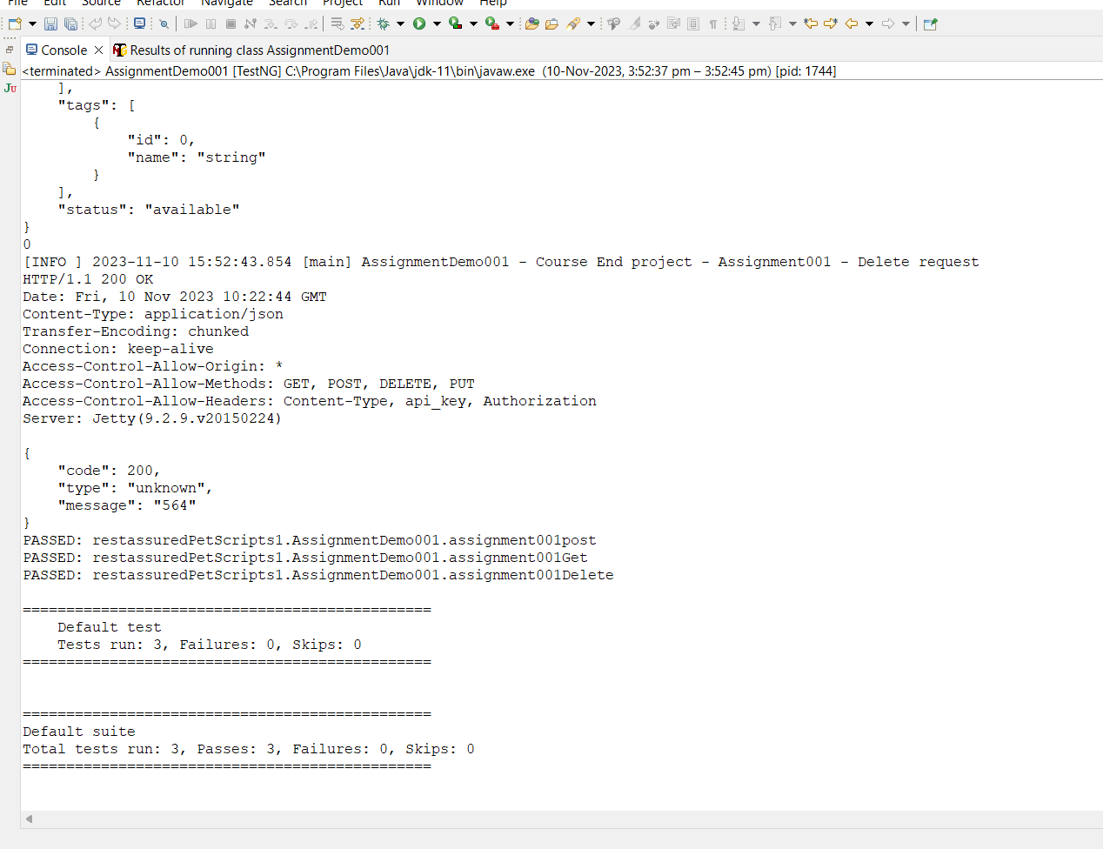

**Assignment-002**

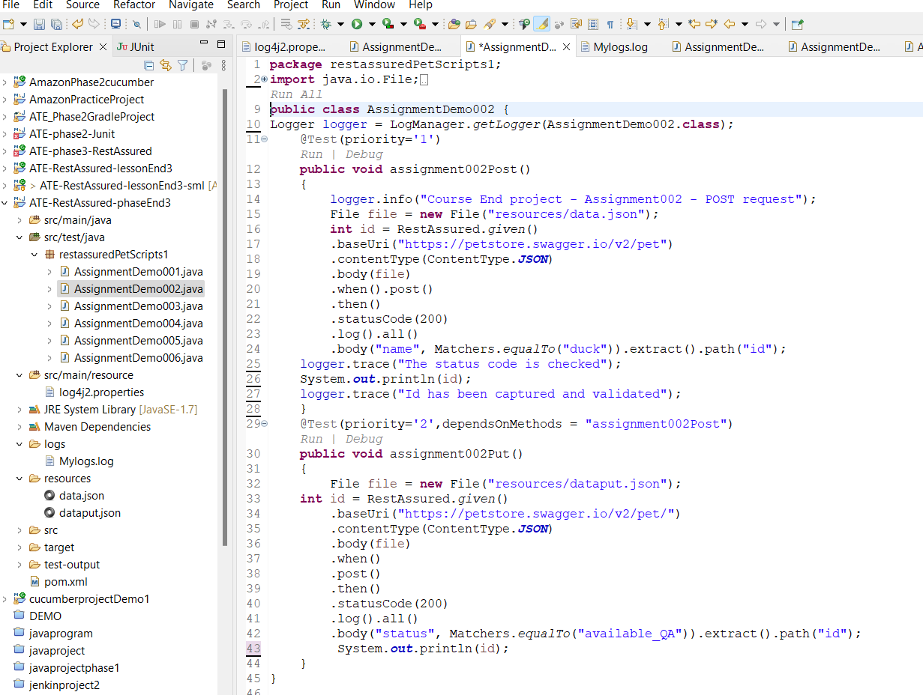

**Dataput.json file-for available QA**

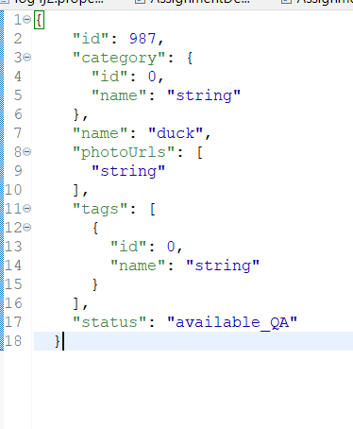

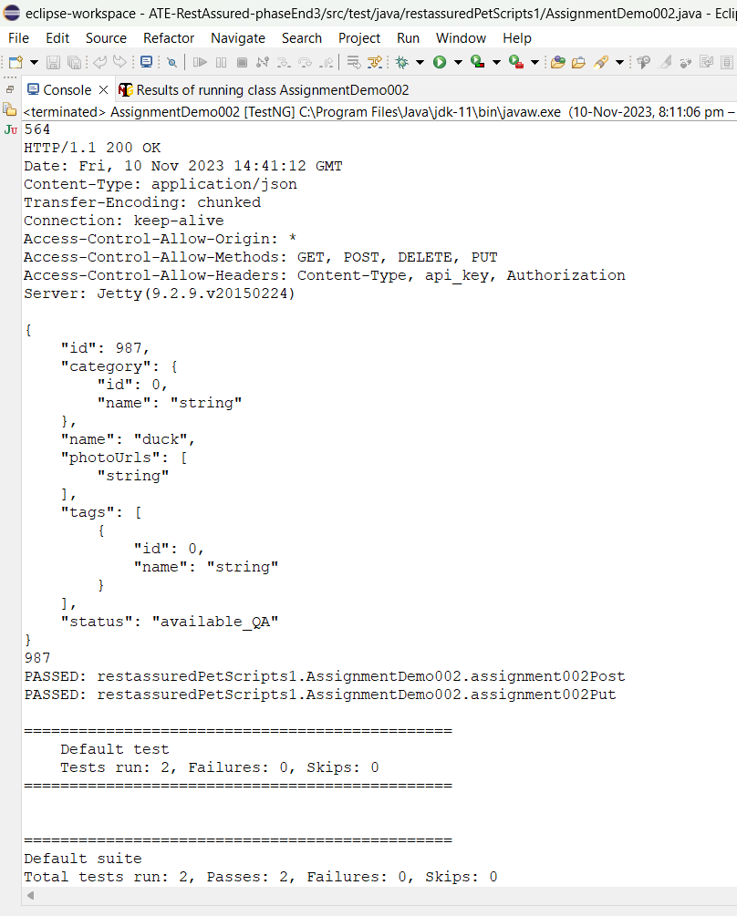

**Available-PROD  
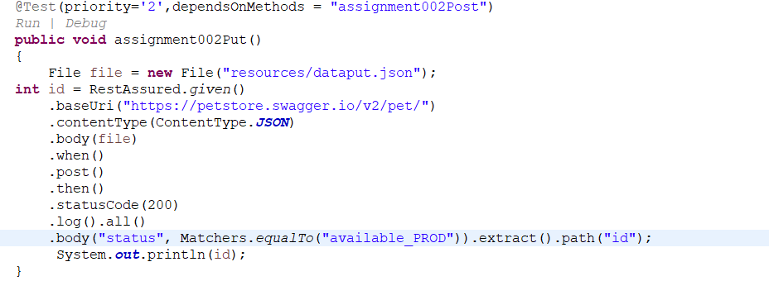**

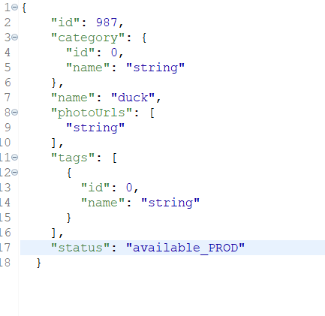

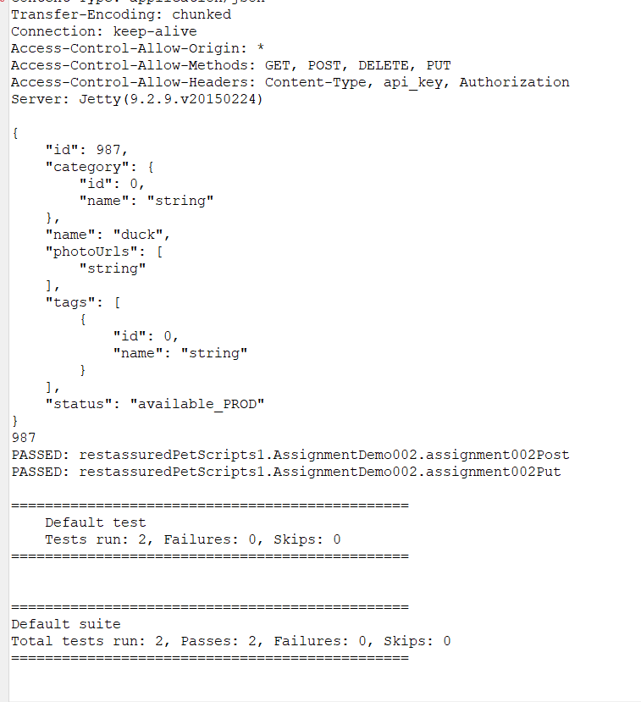

**Available-dev**

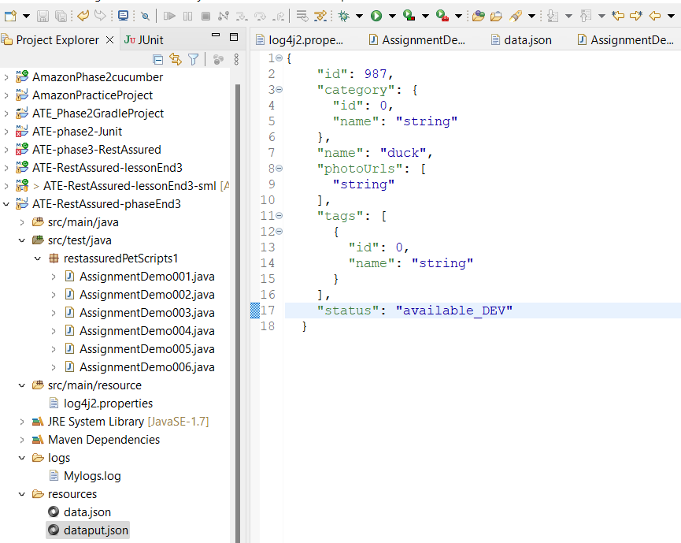

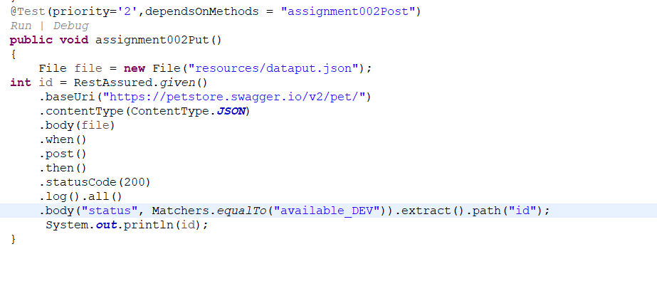

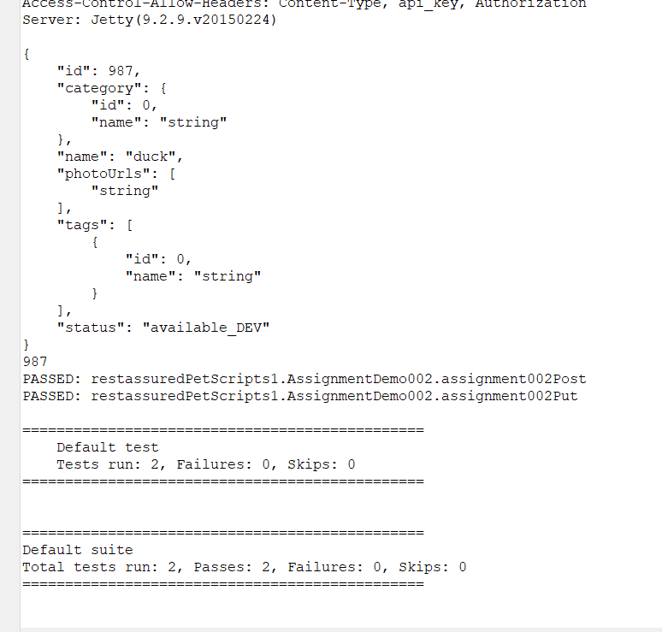

**Assignment-004**

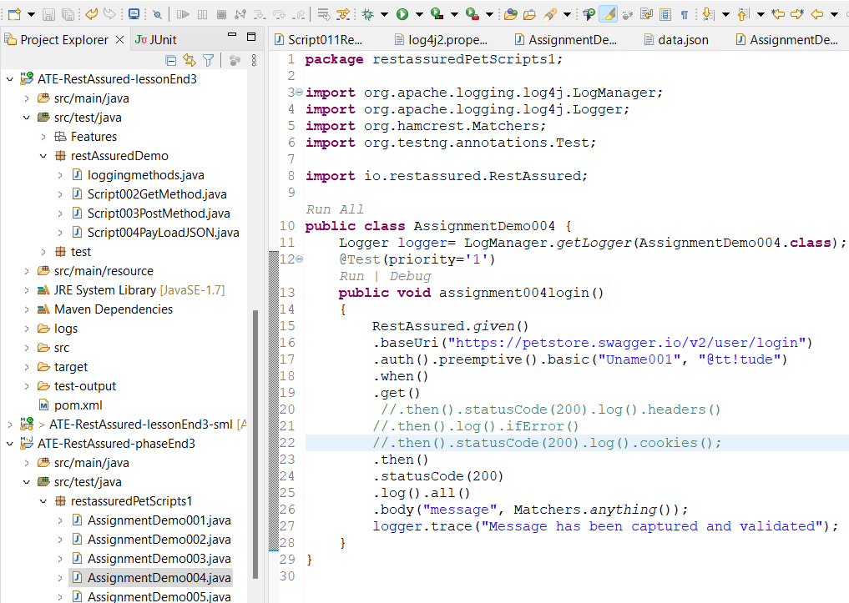

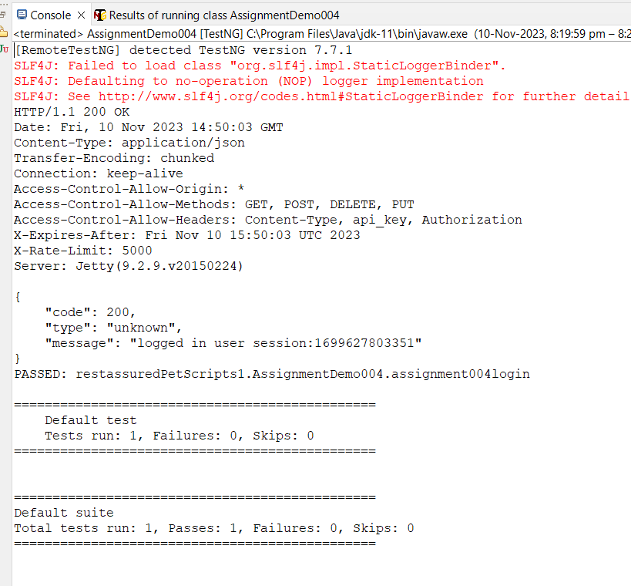

**Assigment-005**

**Status-code**

**Program-1**

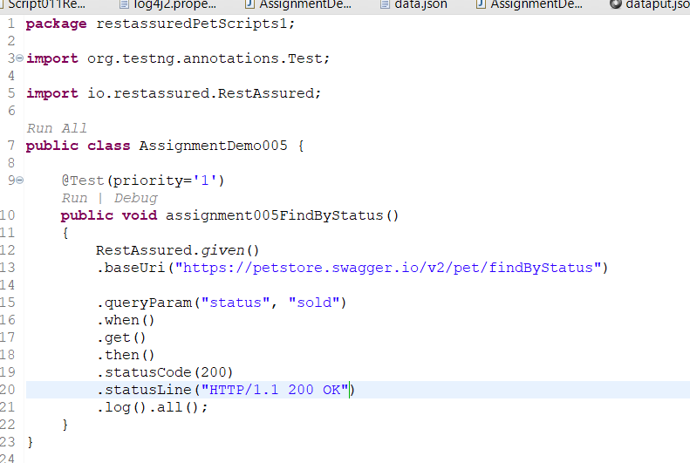

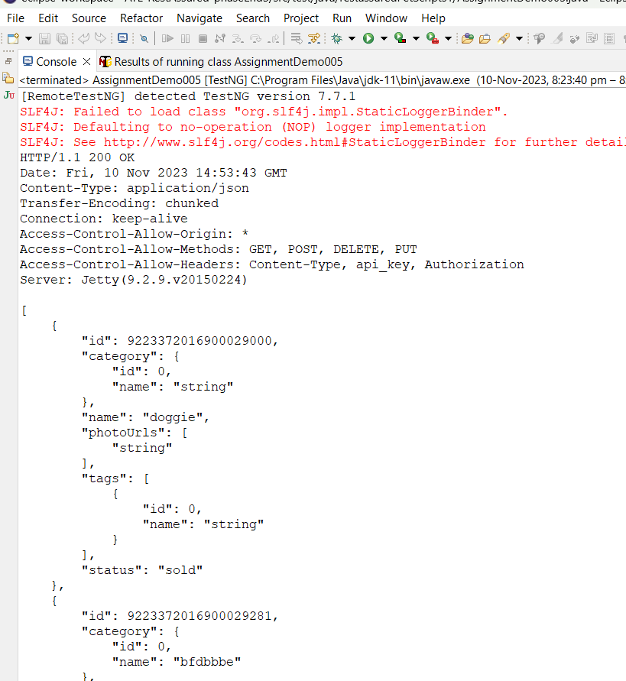

**Program-02**

**Status-available**

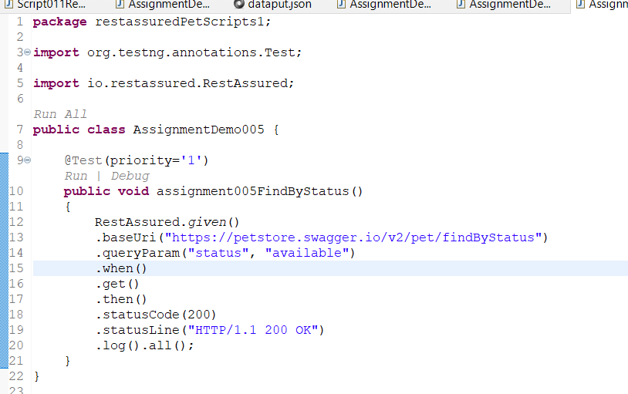

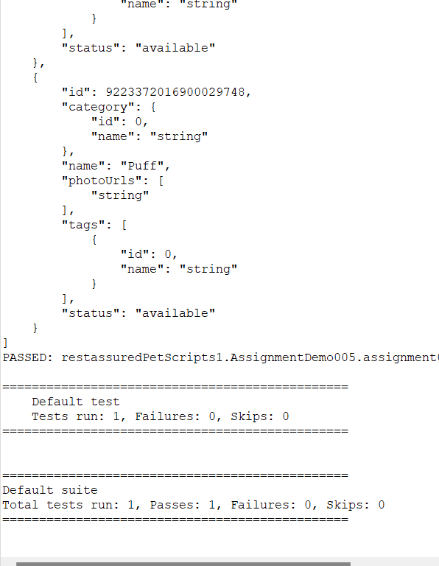

**Program 3**

**Status-pending**

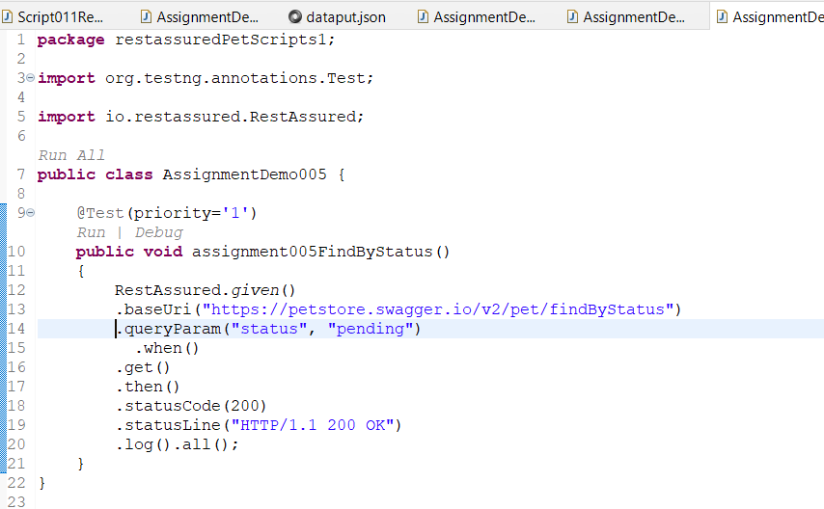

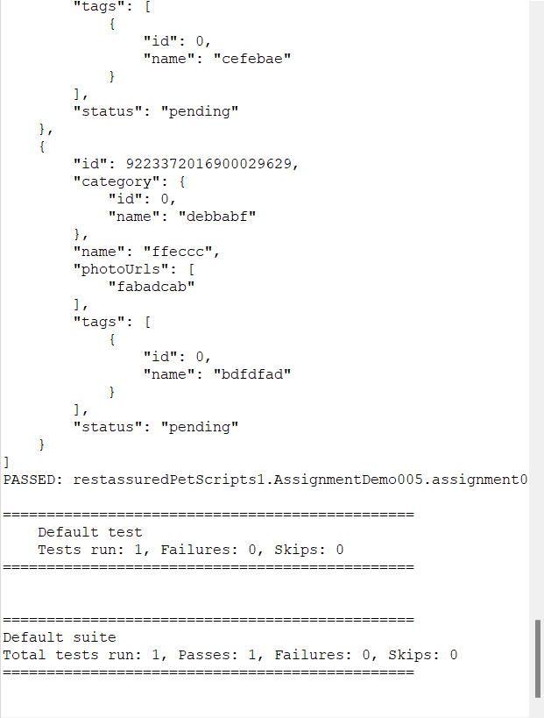

**ASSIGNEMENT_005**

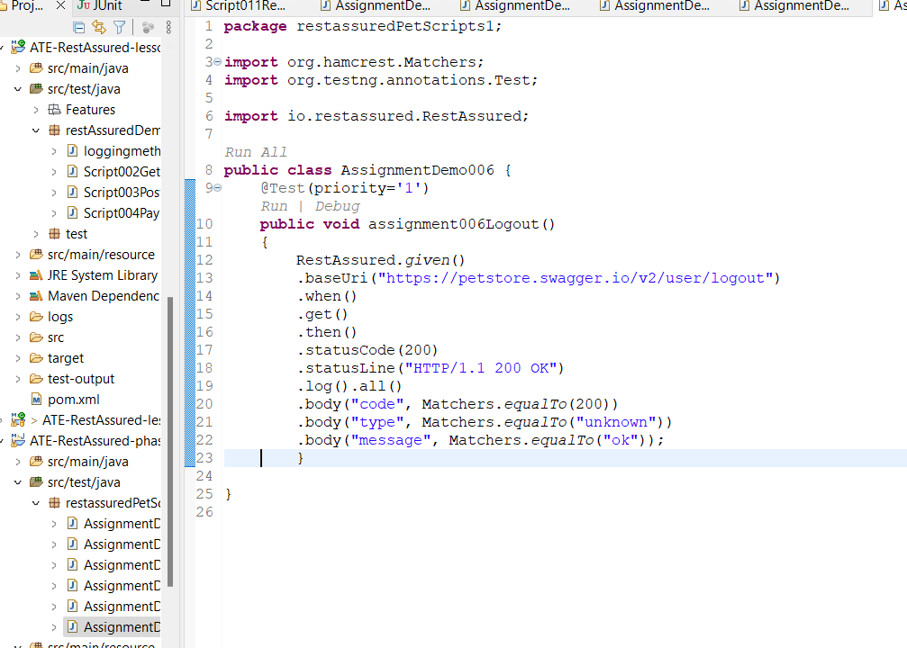

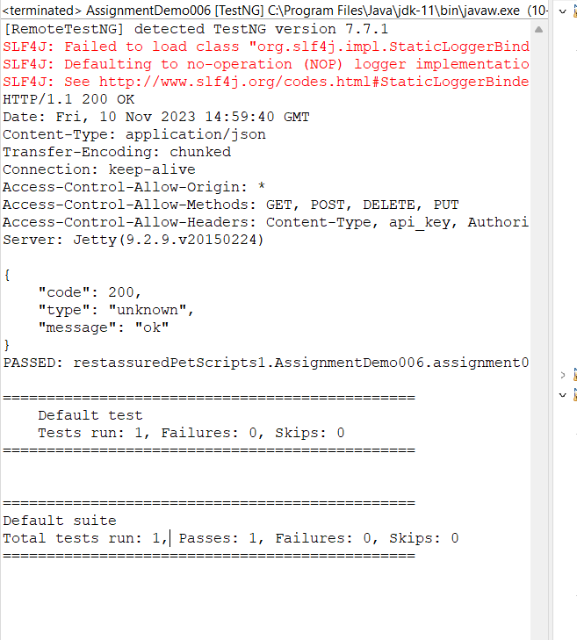

**ASSIGNMENT-003**

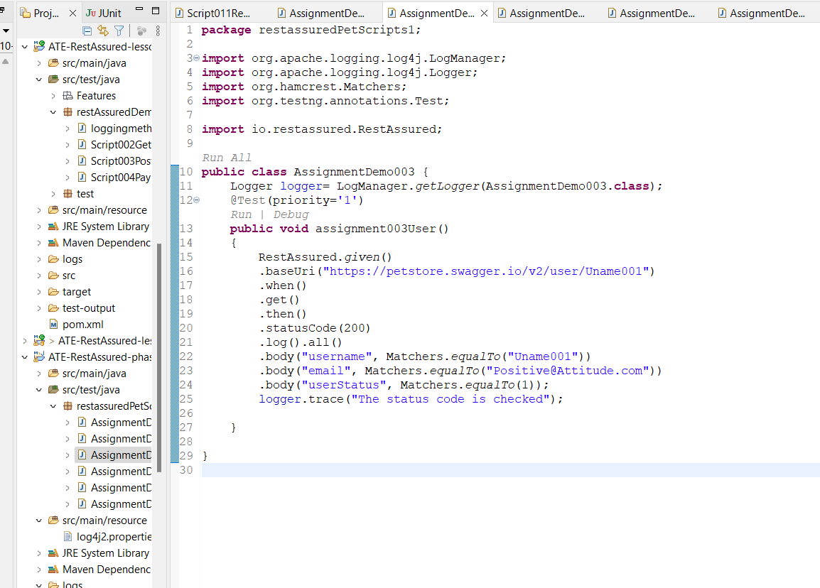

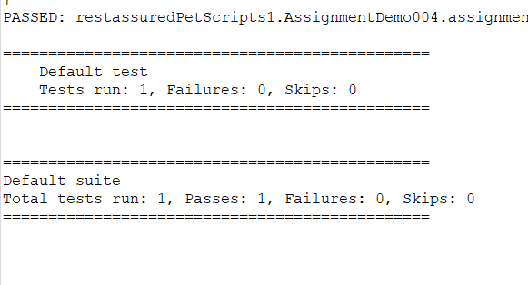

**Poml-file**

